

**Al-Yamamah University**

**College of Engineering and Architecture**

**Department of Software Engineering**

**TD MATCHA STORE**

Prepared by:

**deema alajlan**( 20221278 )

**tabark ahmed** ( 202212509 )

CIS 201 Fundamentals of Web Design

Ms. Sara Alsabeg

(2024/11/13)

Introduction

**TD Matcha** is your online destination for premium, authentic matcha tea and accessories. Our store offers top-quality matcha, along with a selection of tools and gift sets to enhance your tea experience. Browse our **Matcha Tea**, **Accessories**, and **Gift Sets** sections to find everything you need. With easy navigation and a focus on quality, **TD Matcha** makes enjoying matcha simple and enjoyable.Pages

Layout:

Color Scheme:

|  |  |  |
| --- | --- | --- |
| Color | Hexadecimal Value | Used For |
| b84dadbe673e767b95d376a3d93d51df.png  91e76605fd4e667b7a493e53d0a38c53.png | **#FF69B4 & #000000** | Font |
| c2be414d2cc9748b519d720f4bcfce29.png  84aa0bb4438099a703deaae077311c2e.png | **#FFD700& #FFFFF** | Buttons |
| 87de460e655164adfae0aed7c6604a99.png | **#FFE4E1** | Background |
| 91e76605fd4e667b7a493e53d0a38c53.png | **#FF69B4** | Header |
| 91e76605fd4e667b7a493e53d0a38c53.png | **#FF69B4** | Footer |

***The fonts used on our website are Arial, sans-serif.***

Page Hierarchy:

**Index Page (Home Page):**

**Header:**

* Logo (TD Matcha)
* Navigation: Home | About Us | Shop | Contact | Cart

**Footer:**

* About Us
* Contact
* Social Media Links

* **Main Content (Introduction):**

* **Welcome to TD Matcha**   
  Your premium source for authentic matcha tea and accessories.

**Products Page:**

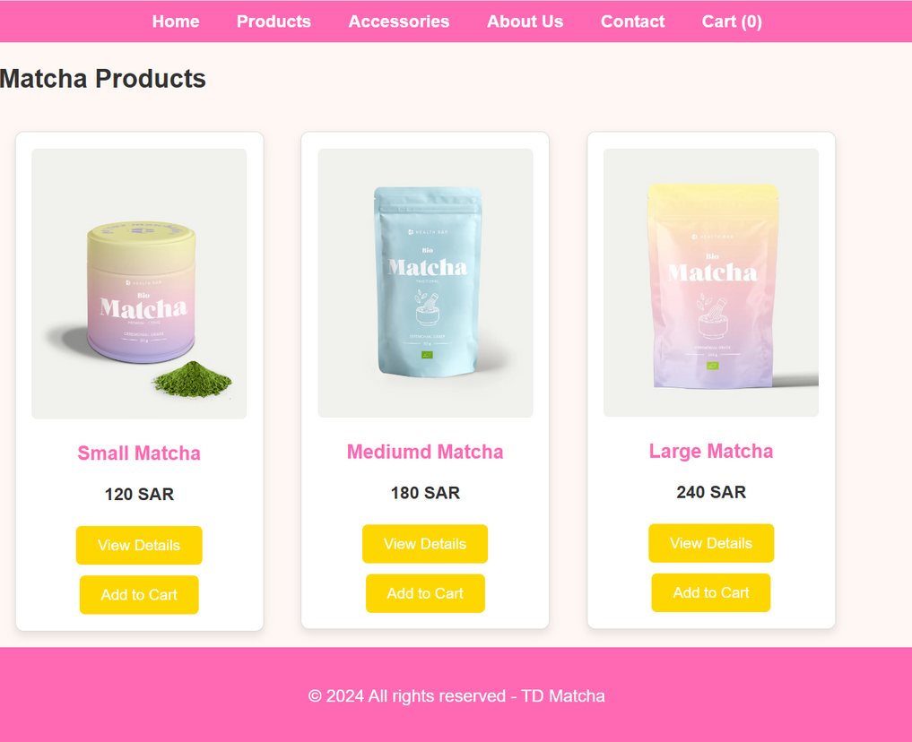

About us Page

**About us Page**

**About Us**

**TD Matcha** was created with a passion for high-quality matcha and the tea ritual. We carefully select premium matcha and accessories to offer the best of this vibrant tradition. Our goal is to make matcha accessible and enjoyable for everyone.

Contact Info:

**Email:** contact@tdmatcha.com

**Phone:** +966-555-555-555

**Address:** TD Matcha Store, Riyadh, Saudi Arabia

**Cart Page**

The cart page displays all the products you’ve added, each with a brief description. You can modify the quantity of any product.

External Links:

For Bootstrap: ?

For CSS:

<link rel="style" href="../src/css/styles.css"> Header/NavBar +products css

For JS:

<script src="../src/js/JavaScript.js"></script> Products Display code + Cart counter

**GITHUB**

<https://github.com/heartlock2004/cis201>